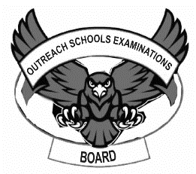**OUTREACH SCHOOLS EXAMINATION BOARD**

**MIDTERM II EXAMINATION 2023**

**Age Group (3 – 4 years): BABY CLASS**

**Learning Area 1: Social Development**

My name is __________________________________________

1. **Oral work.**
2. What is your best colour?
3. What do you use for writing?
4. Where do Moslems go for prayers?
5. What is your friend’s name?
6. Who brings you at school?
7. Who heads a family?
8. 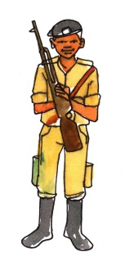**Tell these important people.**

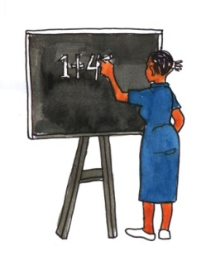

1. **Draw the things at home.**

|  |  |  |
| --- | --- | --- |
|  |  |  |
|  |  |  |
|  |  |  |
|  |  |  |

1. **Trace a mosque.**
2. **Shade a baby.**



**END**